भारतमौसमविज्ञानविभाग |  | India Meteorological Department
Tuesday,17th June 2025 (27 Jyeshtha 1947 Saka)
Summary of observations recorded at 0830 hours IST: Southwest Monsoon has further advanced over some more parts of North Arabian Sea and Gujarat and remaining parts of Vidarbha, more parts of Madhya Pradesh; most parts of Chhattisgarh; remaining parts of Odisha; some parts of Jharkhand; entire Gangetic West Bengal and remaining parts of Sub-Himalayan West Bengal and some parts of Bihar. The Northern Limit of Monsoon passes through 24.0°N/60°E, 24.0°N/65°E, Deesa, Indore, Panchmarhi, Mandla, Ambikapur, Hazaribagh, Supaul and 29.0°N/84.0°E. Conditions are favourable for further advance of Southwest monsoon over remaining parts of North Arabian Sea & Gujarat; some parts of Rajasthan; some more parts of Madhya Pradesh; remaining parts of Chhattisgarh, Jharkhand & Bihar and some parts of East Uttar Pradesh during next 2 days. Under the influence of the upper air cyclonic circulation over northwest Bay of Bengal & neighbourhood, a Low Pressure Area formed over southwest Bangladesh and adjoining Gangetic West Bengal at 0530 hrs IST of today. It persisted over the same region at 0830 hrs IST of today, 17th June 2025. The associated upper air cyclonic circulation extending upto 7.6 km above m. s. l. tilting southwards with height. It is likely to move slowly west-northwestwards and become more marked over Gangetic West Bengal & neighbourhood during next 24 hours. Under the influence of the upper air cyclonic circulation over south Gujarat & neighbourhood, a Low Pressure Area formed over Gujarat & neighbourhood at 0530 hrs IST of today. It persisted over the same region at 0830 hrs IST of today, the 17th June 2025. The associated upper air cyclonic circulation extending upto 5.8 km above m. s. l. tilting southwards with height. It is likely to move nearly northwards during next 24 hours. A trough ran form cyclonic circulation associated with Low Pressure Area over Gujarat region & neighbourhood to Jharkhand across Madhya Pradesh & north Chhattisgarh at 0.9 km above m. s. l. The Western Disturbance as a trough in middle tropospheric westerlies with its axis at 5.8 km above m. s. l. ran roughly along Long. 72°E to the north of Lat. 30°N. The upper air cyclonic circulation over northeast Assam & neighbourhood extending upto 1.5 km above m. s. l. persisted. The upper air cyclonic circulation over south Punjab & neighbourhood became less marked. The upper air cyclonic circulation over northeast Punjab & neighbourhood became less marked.
Day temperatures were markedly above normal(> 5.1°C) at isolated places over Odisha, Bihar, west Uttar Pradesh and Konkan & Goa; appreciably above normal(3.1°C to 5.0°C) at isolated places over Sub Himalayan West Bengal & Sikkim, Himachal Pradesh and Tamil Nadu, Puducherry & Karaikal; at few places over Arunachal Pradesh; at isolated places over Nagaland, Manipur, Mizoram & Tripura, Gangetic West Bengal, east Uttar Pradesh, east Rajasthan, east Madhya Pradesh and Chhattisgarh; near normal(-1.5°C to 1.5°C) at many places over Andaman & Nicobar Islands, Uttarakhand, Punjab, west Madhya Pradesh and Lakshadweep; at most places over Jharkhand, Gujarat Region and Vidarbha; at few places over Assam & Meghalaya, Saurashtra & Kutch, Marathwada, coastal Andhra Pradesh & Yanam, coastal Karnataka and Kerala & Mahe; at isolated places over Haryana-Chandigarh-Delhi, west Rajasthan, Madhya Maharashtra, Telangana, Rayalaseema and north interior Karnataka. The highest maximum temperature of 41.1°C was reported at Chapra (Bihar).
The Southwest Monsoon has been active over Gangetic West Bengal, Odisha, coastal Karnataka and Kerala. It has been subdued over Marathwada and Telangana.
Total 307 stations reported rainfall today. Total rainfall is 476.7 cm. Total 295 stations reported rainfall today whose normals are available. Total rainfall is 432.6 cm with normal station total is 232.2 cm.
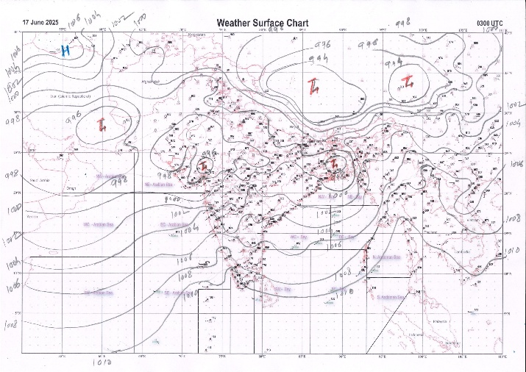 | 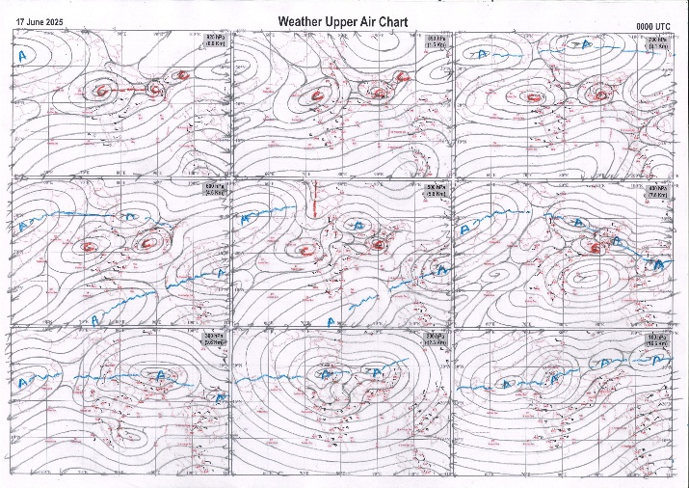
g.1. Analysed surface chart based on 03z observation | Fig.2. Analysed upper air chart based on 00z observation

Dr. S.D.Sanap
Scientist ‘D’
CR & S Office, Pune  Issued at 1245 hrs. IST |  | Weather Forecasting Division  CR&S, Pune

Indian regions | Realised rainfall (chief amount in cm during past 24 hrs):
East | most places: Nagaland-Manipur-Mizoram-Tripura+ and West Bengal & Sikkim+++  many places: Arunachal Pradesh+, Assam & Meghalaya+, Odisha+++ and Jharkhand+  isolated places: Bihar+  Pto tarakeswar 14.6, Deogarh 13.4, Sagar island PTO 12.3, Neamatighat 10.6, Jenapur 9.5, Naharlagun AWS 8.7, Karballa tea estate 8.6, Andar 8.5, Itanagar 8.2, Jharsuguda & Panchet dvc 7.3 each, Singimari 7.2, Jorhat 7.1, Thoubal 6.8, Bandgaon 6.7, Kohima 6.5, Cherrapunji (rkm) 5.9, Hussainganj 5.6, Bhagalpur 5.4, Belonia 5.0, Bankura 4.9, Cooch behar 2.7, Dhanbad 2.0, Tezu 0.6.
North | most places: Himachal Pradesh+  many places: east Rajasthan+  a few places: east Uttar Pradesh+, Haryana and Punjab+  isolated places: west Uttar Pradesh, Uttarakhand, Jammu-Kashmir and Ladakh and west Rajasthan  Ludhiana 11.2, Mehre (barsar) 9.0, Halwara IAF 8.3, Sikar 7.4, Shardanagar 6.6, Balasmand AWS 6.3, Hissar & Baldwara 6.2 each, Parbatsar 6.1, Srimadhopur 6.0, Ropar kvk AWS 5.9, Ajmer tehsil SR 5.6, Bansi CWC 5.4, Una 5.2, Narnound REV & Nawa 5.1 each, Basti CWC 3.8, Didihat 3.5, Pauri 2.8, Mussoorie 2.2, Etah 1.9, Sonemarg dual AWS 0.9, Thoise (iaf) & Pahalgam 0.7 each, Lalitpur & Aligarh 0.5 each, Nagaur tehsil SR 0.3.
Central | many places: Vidarbha  a few places: west Madhya Pradesh+, east Madhya Pradesh and Chhattisgarh+  Biaora 9.0, Kusmi 7.3, Gidam 7.0, Badwara 6.4, Jawad 4.9, Bina 3.7, Nowgong 3.2, Vidisha 2.8, Arni 2.7, Ballarpur 2.3, Ambikapur 2.0, Washim 1.0.
Peninsula | most places: Saurashtra & Kutch#, Konkan & Goa+++, coastal Karnataka+++ and Kerala+++  many places: Gujarat Region+ and Madhya Maharashtra+++  a few places: coastal Andhra Pradesh and south interior Karnataka+++  isolated places: Marathwada, Telangana, Tamil Nadu# and north interior Karnataka  dry weather: Rayalaseema  Gadhda 35.7, Palitana 28.8, Mahuva (b) 22.5, Avalanche 20.7, Bhagamandala 19.5, Gersoppa 17.0, Agumbe emo 13.9, Panathur AWS 13.7, Siddapura 13.1, Muliyar AWS 13.0, Radhanagari 12.8, Bhiwandi 12.6, Matheran 11.5, Hansot 11.1, Rajapur 11.0, Igatpuri 10.9, Upper bhavani 9.9, Dhandhuka 9.4, Kammardi 9.3, Honavar 9.1, Valparai PTO 8.7, Mahabaleshwar 8.5, Kannur 8.0, Bharuch 7.3, Londa 5.0, Khanapur 4.1, Jiyyamma valasa 3.9, Belampalle 2.8, Sirpur (t) 2.7, Polavaram 1.8, Himayatnagar 1.6, Parbhani , Tondapur ARG, Kakinada & Raichur PTO 0.9 each, Mahbubnagar 0.3.
Islands | most places: Andaman & Nicobar  many places: Lakshadweep  Long island 2.5, Maya bandar 2.0, Amini 1.9, Car Nicobar 1.8, Agathi 1.5.
Table 2. Forecast / warnings (distribution of rain / thundershowers) for 7 days (valid from time of origin upto 0830 hrs IST of next day)
Sr N. |  | Sub-division Name | Day 1 | Day 2 | Day 3 | Day 4 | Day 5 | Day 6 | Day 7 | Sr. No. | Sub-division Name | Day 1 | Day 2 | Day 3 | Day 4 | Day 5 | Day 6 | Day 7
 |  |  | 17 Jun | 18 Jun | 19 Jun | 20 Jun | 21 Jun | 22 Jun | 23 Jun |  |  | 17 Jun | 18 Jun | 19 Jun | 20 Jun | 21 Jun | 22 Jun | 23 Jun
 | 1 | Andaman Nicobar Islands | F  | W  | W | W | W | W | W | 19 | west Madhya Pradesh | F +  | S+  | F | F+ | W+  | W | W+
 | 2 | Arunachal Pradesh | W ++  | W ++  | W++  | W++  | F +  | F + | F +  | 20 | east Madhya Pradesh | S +  | S  | F | W++ | W++ | W | W++
 | 3 | Assam-Meghalaya | W++ | W # | W# | W++  | F +  | F + | W +  | 21 | Gujarat region | W # | W++ | F++ | F + | W + | W+ | W +
 | 4 | Nagaland-Manipur-Mizoram-Tripura | W++ | W++  | W++ | W ++  | W++  | W ++ | W ++ | 22 | Saurashtra and Kutch | W # | W++ | F+  | F | F | W+ | F
 | 5 | Sub Himalayan West Bengal/Sikkim | W+ | W+ | W+  | W | W | F | F | 23 | Konkan and Goa | W ++ | W++ | W ++ | W + | W + | W + | W +
 | 6 | Gangetic West Bengal | W # | W # | W + | F | F | F | W | 24 | Madhya Maharashtra | I++  | S ++ | I++  | I + | I + | I + | I +
 | 7 | Odisha | W++ | W # | W ++ | F + | S | S | S | 25 | Marathwada | I | I  | I  | I  | I | I | I
 | 8 | Jharkhand | W++ | W # | W # | W++ | F + | F | F + | 26 | Vidarbha | F  | S  | S  | S  | S  | S | S 
 | 9 | Bihar | S +  | F++  | F++ | F + | F + | S | S + | 27 | Chhattisgarh | F++  | F ++  | F++  | F ++  | F +  | S  | S + 
 | 10 | east Uttar Pradesh | S  | F+  | W++ | W++ | F +  | F + | S +  | 28 | Coastal Andhra Pradesh and Yanam | I  | I  | I  | I  | I  | I | I 
 | 11 | west Uttar Pradesh | I  | S  | F +  | W++ | F++  | S +  | S++ | 29 | Telangana | I  | I  | I  | I  | I  | I | I 
 | 12 | Uttarakhand | F +  | F+  | F + | F+  | F+  | F+ | F+  | 30 | Rayalaseema | I  | I  | I  | I  | I  | I | I 
 | 13 | Haryana,Chandigarh and Delhi | S+  | S  | I  | F+  | F+  | F+ | S +  | 31 | Tamil Nadu, Puducherry and Karaikal | I ++  | I + | I | I | I | I | I
 | 14 | Punjab | S + | I  | I  | S  | F+  | F+ | S+  | 32 | Coastal Karnataka | W # | W++ | W+  | W | W | W | W
 | 15 | Himachal Pradesh | W  | S  | S  | F +  | F +  | F +  | F +  | 33 | North interior Karnataka | S +  | S  | I  | I | I | I | I
 | 16 | Jammu-Kashmir and Ladakh | I +  | I | I | I | F  | W+ | S  | 34 | South interior Karnataka | F # | S+  | I  | I | I | I | I
 | 17 | west Rajasthan | I  | I  | I  | I  | I  | S  | S  | 35 | Kerala and Mahe | W ++ | W + | F + | F | F | F | F
 | 18 | east Rajasthan | S + | S+  | S+  | S +  | F+  | F+  | F+  | 36 | Lakshadweep | W | W | F | F | F | F | F
Legends: D = Dry I = Isolated S = Scattered F = Fairly widespread W = Widespread #= heavy to very heavy rain at a few places with extremely heavy rain at isolated places +++= heavy rain at a few places with very heavy rain at Isolated places ++= heavy to very heavy rainfall @=Isolated exceptionally heavy rainfall + = heavy rain ●/*= rain or snow ♦ = very light rain ≡=fog= thunderstorm with lightning =Squall / Gusty / gale / strong wind ­ =cold wave/cold day += heat wave/warm night/hot and humid weathe r=Duststorm =ground frost = Hail
Fig. 4: Districtwise warnings for five days for Maharashtra State
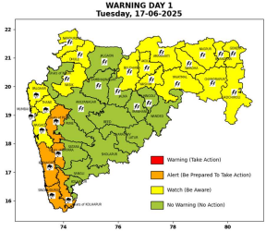 | 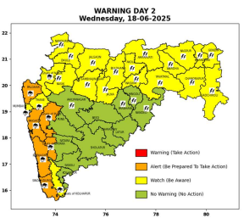 | 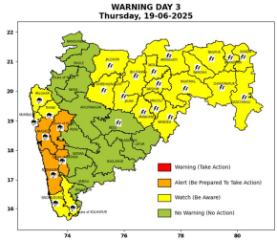 | 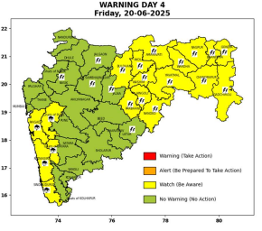 | 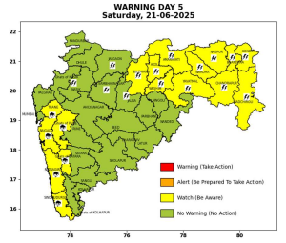

Pune, Lohegaon and Pashan observations at 0830 hrs. IST of Today
 | Temperature (°C) |  |  |  |  | Humidity (%) |  |  |  | Rainfall (mm)
 | Max.  past  24 hrs | Dep.  from  normal | Min.  past  24 hrs. | Dep.  from  normal | Dry  Bulb | At 0830 hrs. IST | Dep.  From  normal | At 1730  hrs. IST of y’day | Dep.  from  normal | Past  24 hrs. | Since  1st June | Dep.  from  normal
PNE | 26.2 | -4.7 | 22.3 | -0.6 | 26.2 | 79 | 0 | 92 | 22 | 9.4 | 172.9 | 83.2
PSN | 24.1 | - | 21.0 | - | 24.6 | 90 | - | 97 | - | 11.1 | 192.7 | -
LHG | 27.7 | -4.3 | 24.0 | 3.0 | 28.1 | 66 | -10 | 86 | 24 | 7.4 | 168.6 | 110.5

 |  |  |  |  |  |  | Local (Pune and neighbourhood) forecast
Max./Min. Temperature (°C) |  |  |  |  |  |  |  |  | Weather
Date | Pune | Pashan | Lohegaon | Chinchwad | Lavale | Magarpatta | NDA | Koregoan Park
17/06/25 | 31 / 22.3* | 30 / 21.0* | 32 / 24.0* | 31 / 21.4* | 30 / 21.9* | 31 / 23.6* | 30 / 22.9* | 31 / 23.5* | Generally cloudy sky. Light to moderate rain very likely.
18/06/25 | 31 / 22 | 30 / 21 | 32 / 24 | 31 / 21 | 30 / 22 | 32 / 23 | 30 / 23 | 32 / 23 | Generally cloudy sky. Light rain very likely.
19/06/25 | 30 / 23 | 29 / 22 | 31 / 25 | 30 / 22 | 29 / 23 | 31 / 24 | 29 / 24 | 31 / 24 | Generally cloudy sky. Light rain very likely.
20/06/25 | 30 / 23 | 29 / 22 | 31 / 25 | 30 / 22 | 29 / 23 | 31 / 24 | 29 / 24 | 31 / 24 | Generally cloudy sky. Light rain very likely.
21/06/25 | 31 / 23 | 30 / 22 | 32 / 25 | 31 / 22 | 30 / 23 | 32 / 24 | 30 / 24 | 32 / 24 | Generally cloudy sky. Light rain very likely.
22/06/25 | 31 / 22 | 30 / 21 | 32 / 24 | 31 / 21 | 30 / 22 | 32 / 23 | 30 / 23 | 32 / 23 | Generally cloudy sky. Light rain likely.
23/06/25 | 30 / 22 | 29 / 21 | 31 / 24 | 30 / 21 | 29 / 22 | 31 / 23 | 29 / 23 | 31 / 23 | Generally cloudy sky. Light to moderate rain likely.
Rainfall Distribution |  |  | Rainfall Categories | Rainfall (mm) |  | Cloud condition |  |  |  | Rainfall Intensity |  | Range
Widespread (W) | 76-100% |  | Very Light rain | Trace to 2.4 mm |  | Mainly clear sky |  | 1-2 oktas |  | Light Spell |  | 1 cm/hr
 |  |  | Light rain | 2.5 to 15.5 mm |  | Partly cloudy sky |  | 3-4 oktas |  | Moderate Spell |  | 1-2 cm/hr
Fairly Widespread (FW) | 51 – 75% |  | Moderate rain | 15.6 to 64.4 mm |  | Generally cloudy sky |  | 5-7 oktas |  | Intense Spell |  | 2-3 cm/hr
Scattered (S) | 26 – 50% |  | Heavy rain | 64.5 to 115.5 mm |  | Overcast |  | 8 oktas |  | Very Intense Spell |  | 3-5 cm/hr
isolated (I) | 1 – 25% |  | Very heavy rain | 115.6 to 204.4 mm |  |  |  |  |  | Extremely Intense Spell |  | 5-10 cm/hr
D (D) | No Rain |  | Extremely heavy rain | ≥ 204.5 mm |  |  |  |  |  | Cloudburst |  | > 10 cm/hr
Probability Terms in %: |  |  | Heavy snow | 6.5 to 11.5 cms water equivalent of rain
unlikely | < 25 |  | Very heavy snow | 11.6 to 20.4 cms water equivalent of rain
likely | between 25 50
very likely | between 51 75
most likely | >75
* = realized temperature
Mumbai (Colaba) |  |  |  | Nagpur (AP)
Date 2025 | T max °C | T min °C | Weather | T max °C | T min °C | Weather
17/06 | 30 | 26 | Generally cloudy sky with intermittent heavy rainfall. | 38 | 26 | Rain or thundershowers accompanied with lightning & gusty winds(30-40kmph).
18/06 | 31 | 26 | Generally cloudy sky with Heavy rainfall. | 37 | 26 | Thunderstorm accompanied with lightning and rain.
19/06 | 32 | 25 | Generally cloudy sky with Heavy rainfall. | 37 | 26 | Thunderstorm accompanied with lightning and rain.
20/06 | 32 | 25 | Generally cloudy sky with moderate rain. | 37 | 25 | Partly cloudy sky with possibility of development of thunder lightning.
21/06 | 31 | 24 | Generally cloudy sky with intermittent heavy rainfall. | 37 | 25 | Partly cloudy sky with possibility of development of thunder lightning.
22/06 | 31 | 24 | Rain. | 36 | 25 | Mainly clear sky.
23/06 | 31 | 24 | Rain. | 36 | 25 | Mainly clear sky.

